HSVap

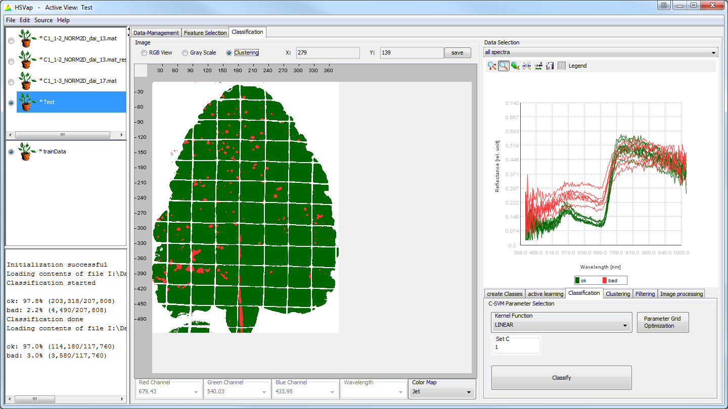

# Creating an SVM-Model

1. Load hyperspectral image: File > Load Data File (Ctrl + L)
2. Switch to “Classification” tab  
   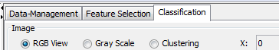
3. Create class by clicking on “add Class” followed by entering a class name and selecting a color  
   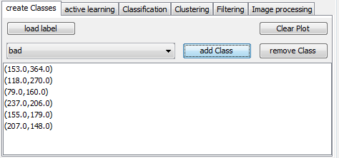
4. Select known pixels by clicking on the image (zoom in/out using the mouse wheel)  
   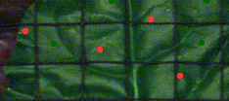
5. Select “Classification” tab on the bottom right  
   I:\Daten\HSVap\Screenshots #2\Ausschnitte\04-1.png
6. Select the wanted Kernel function and fill out parameters
7. Press “Classify” to start classification and give the created SVM model a name
8. To see the result, select the new file on the top left and “Clustering” as representation  
   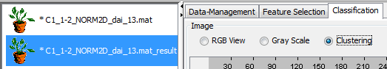

# Applying an SVM-Model

1. Load hyperspectral image: File > Load Data File (Ctrl + L)
2. Select the previously created SVM model in the “Data-Management” tab  
   I:\Daten\HSVap\Screenshots #2\Ausschnitte\06-1.png
3. Type in a name for the new result and press “Apply”
4. To see the result, select the new file on the top left , switch to the “Classification” tab and select “Clustering” as the representation  
   